**Module (HTML)-1**

• Are the HTML tags and elements the same thing?

* No, the HTML tags and elements are not the same things. HTML tags are used to hold the HTML element. HTML element holds the content. HTML tags start with < and ends with > and whatever written within a HTML tag are HTML elements.

• What are tags and attributes in HTML?

* HTML tags are used to hold the HTML element. HTML attributes means who change the behaviour of HTML element.

• What are void elements in HTML? With Example.

* In HTML self-closing elements are known as void element. For example <area>, <base>, <br>, <col>, <command>, <embed>, <hr>, <img>, <input>, <keygen>, <link>, <meta>, <param>, <source>, <track>, <wbr> etc.

• What are HTML Entities? With Example.

* An HTML entity is a piece of text (“string”) that begins with an ampersand (&) and ends with a semicolon (;). HTML entities are frequently used to display reserved characters (which would otherwise be interpreted as HTML Code), and invisible characters (like non-breaking spaces). For Example
* ‘ Single quotation Mark &apos;
* ₵ cent &cent;
* £ pound &pound;
* ¥ yen &yen;

• What are different types of lists in HTML? With Example.

* There are three different types of lists in HTML (1) Ordered List or Numbered List (ol) (2) Unordered List or Bulleted List (ul) (3) Description List or Definition List (dl).
* There are five types of Ordered List (ol): (1) Number (2) Capital Alphabet (3) Small Alphabet (4) Capital Roman and (5) Small Roman
* There are three types of Unordered List (ul): (1) Disc (2) Circle (3) Square

• What is the ‘class’ attribute in HTML? With Example.

* The class attribute specifies one or more classnames for an element. The class attribute is mostly used to point to a class in a style sheet. However, it can also be used by a JavaScript (via the HTML DOM) to make changes to HTML elements with a specified class.

• What is the difference between the ‘id’ attribute and the ‘class’ attribute of HTML elements? With Example.

* The only difference between ‘id’ attribute and the ‘class’ attribute is that ‘id’ is unique in a page and can only apply to at most one element, while ‘class’ selector can apply to multiple elements.

• What are the various formatting tags in HTML?

* The various formatting tags in HTML are Bold text <b>, Important text <strong>, Italic text <i>, Emphasized text <em>, Underline text <u>, Inserted text <ins>, Deleted text <del>, Strike text <strike>, Monospacing text <tt>, Subscript text <sub>, Superscript text <sup>, Abbreviation text <abbr>, Address text <address>, Details (Definition) text <details>, Summary text <summary> etc.

• How is Cell Padding different from Cell Spacing? With Example.

* Cellpadding basically defines the space present between a table cell’s border and the content present in it.
* Cellspacing basically defines the space present between individual adjacent cells.

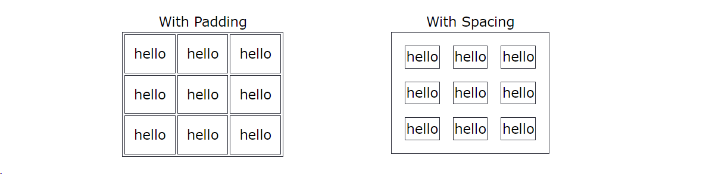

• How can we club two or more rows or columns into a single row or column in an HTML table? With Example.

* It can be done by using the rowspan and colspan attribute in HTML. The rowspan is used to merge or combine the number of cells in a row whereas the colspan is used to merge column cells in a table.

• What is the difference between a block-level element and an inline element?

* Inline elements only cover the space as bounded by the tags in the HTML element. Block elements have top and bottom margins. Inline elements don’t have a top and bottom margin. Example of block elements - <p>,<div>,<hr>. Example of inline elements - <span>

• How to create a Hyperlink in HTML? With Example.

* Use the <a> element to define a link. Use the href attribute to define the link address. Use the target attribute to define where to open the linked document. For Example <a href=”http:www.example.com”>Example</a>

• What is the use of an iframe tag? With Example.

* The most common use of an iframe is to load content from another site within the page. Using an iframe is the accepted way to embed a YouTube video or Google Maps content.

• What is the use of a span tag? Explain with example?

* The <span> tag is an inline container used to mark up a part of a text, or a part of a document. The <span> tag is easily styled by CSS or manipulated with JavaScript using the class or id attribute. The <span> tag is much like the <div> element, but <div> is a block-level element and <span> is an inline element.

• How to insert a picture into a background image of a web page? With Example.

* Using the <img> element and src attribute we can insert a picture into a background image of web page. For example - <img src=”house.jpg” align=”center”>

• How are active links different from normal links?

* Active links are typically links that are currently functional and lead to live web pages, while normal links can refer to any link, whether functional broken. Active links are actively used and accessible, while normal links may or may not be functional at a given time.

• What are the different tags to separate sections of text?

* Using the below tags separate a section of texts in HTML:
* <br> tag -It is used to separate the line of text. It breaks the current line and shifts the flow of the text to a new line.
* <p> tag – This tag is used to write a paragraph of text.
* <blockquote> tag – This tag is used to define large quoted sections.

• What is SVG?

* SVG stands for Scalable Vector Graphics. SVG defines vector-based graphics in XML format. The SVG file format is a popular tool for displaying two-dimensional graphics, charts and illustration on websites. Plus, as a vector file, it can be scaled up or down without losing any of its resolution.

• What is difference between HTML and XHTML?

* HTML (Hyper Text Markup Language) and XHTML (Extensible Hyper Text Markup Language) are both markup languages used for creating and displaying web pages. The main difference between them is the syntax and structure; HTML is more lenient in its syntax, while XHTML has a more strict syntax and follows XML rules.

• What are logical and physical tags in HTML?

* Physical and Logical tags are used in HTML for better visibility and understanding of the text by the user on the web page. However, both tags differ from each other as suggested by their names. Logical Tags are used in HTML to display the text according to the logical styles.